**PROJECT SYNOPSIS**

**TITLE:**

**FrontDesk** - An Online Event Registration App

**ABSTRACT:**

Web-based app for **event registrations, ticketing, transactions**. Can be used for **college fests, events, workshops**, etc.

**KEY FEATURES:**

* Real-time updates on event details
* UPI transactions
* Encrypted DB & Secure Authentication
* Secure M-Ticket
* Whatsapp Integration
* Summary, Maintenance & Analytics
* Hierarchical Access Rights & User Account
* Intuitive, fascinating & Responsive UI/UX

**TEAM:**

|  |  |
| --- | --- |
| **NAME** | **USN** |
| Menahi Shayan | 1AM17CS101 |
| P Vamshi Prasad | 1AM17CS127 |
| Nishank Swamy D N | 1AM17CS121 |
| Podaralla Revathi | 1AM17CS132 |

**HARDWARE/SOFTWARE USED:**

* MySQL
* HTML5
* CSS
* JS
* Node-JS
* Electron-JS
* Approx. 500 MB of Disk Space
* Approx. 100 MB of Internet

**PRIVACY POLICY:**

<http://tiny.cc/m9hgdz>

**E R DIAGRAM:**

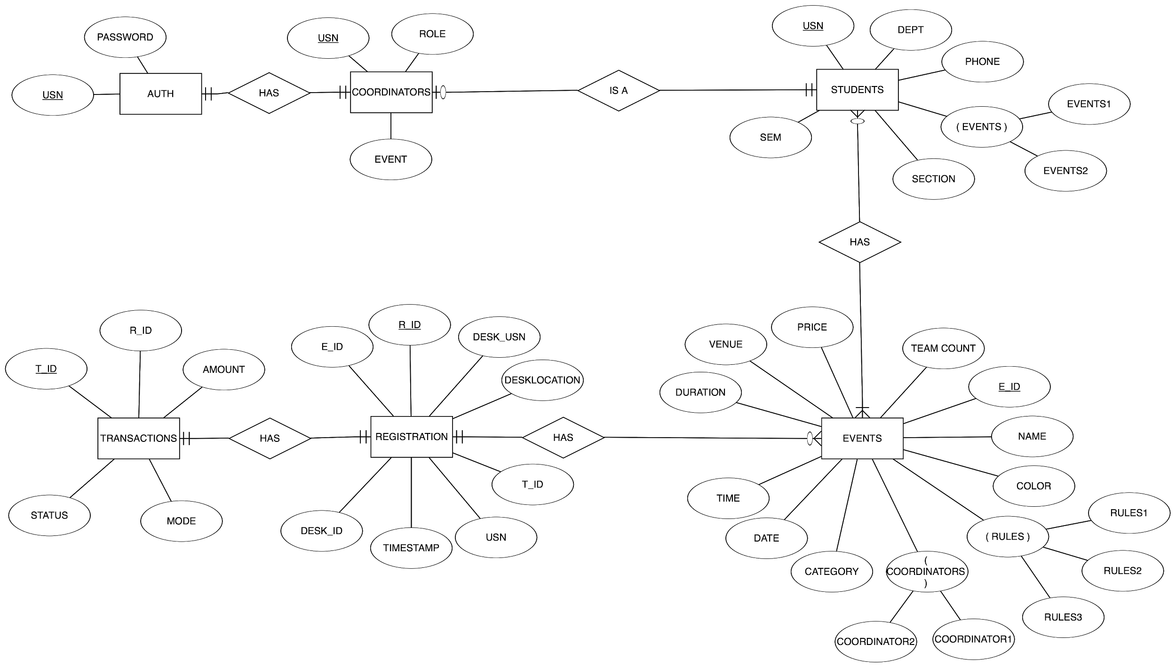

**SCHEMA DIAGRAM:**

